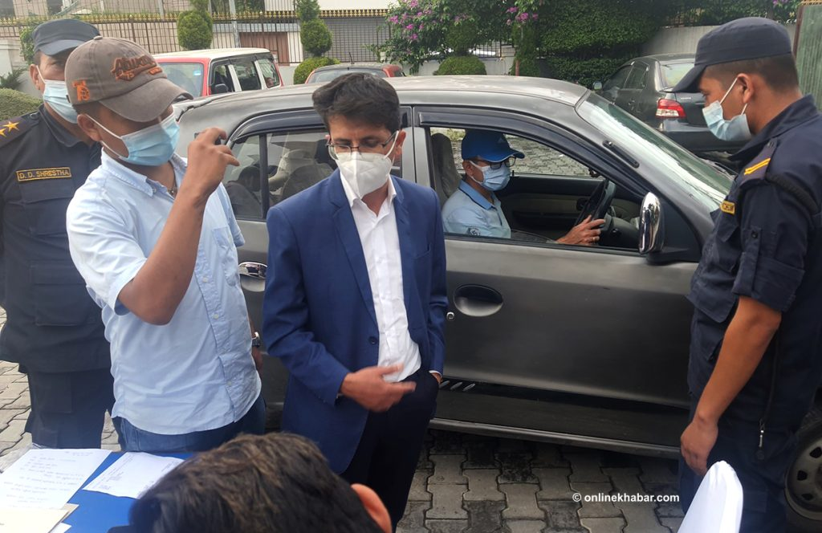Gold medalist bureaucrat Pramod Nepal is arrested with a bribe red-handed in Kathmandu on Tuesday, August 2, 2022.
Kathmandu, August 3
Pramod Nepal, an undersecretary at the Ministry of Culture and Tourism, known among his colleagues for his academic excellence including a gold medal feat, has been arrested red-handed with Rs 2.25 million in a bribe.
Acting on a tip-off, a team deployed from the Commission for the Investigation of Abuse of Authority arrested Nepal at a hotel in Naxal of Kathmandu on Tuesday evening. The anti-corruption constitutional body says it was informed of Nepal demanding the bribe for a paragliding licence.
A Tribhuvan University gold medalist in economics, Nepal is one among 12 Nepali scholars who received the prestigious Chevening Scholarship from the British government in 2020. It has just been eight months since he returned home from Nottingham University and resumed work.
Whereas the commission’s team arrested him with Rs 600,000, an additional 1.65 million was found in the government vehicle used by him.
Nepal was the chief of the Aviation Industry and International Relationships Section at the ministry.
The commission says it will present Pramod Nepal before the Special Court on Wednesday and continue further investigation after receiving permission to remand him.

